
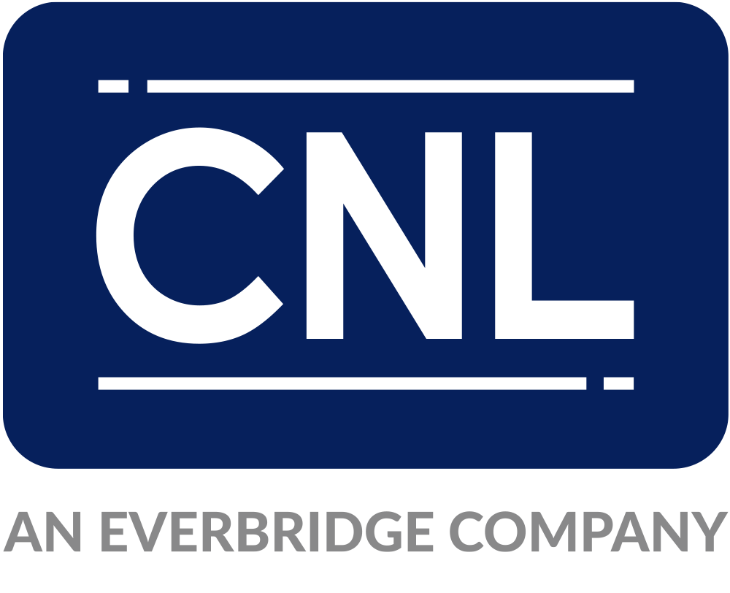

Release Notes
Spotter Global Radar [VERSION]
Last update date: 25 Mar 2025

CONNECTOR DETAILS
Manufacturer | Spotter Global
Product name | Radar
Product category | Other
Connector Package Name | Evbg.CC.Driver.SpotterGlobal.Radar.Version.[FULLVERSION].ipscdriver
Connector version | [VERSION]
Supported Hardware
SDK/API version
Supported Control Center Version | 5.x
Tested against | [Control Center version range]
License Type | Other

www.everbridge.com

